

Discipline: Programming on Python II
Midterm Project
Title of project: Airline Reservation System
Instructor: Zhumakan Aitgul
Team: Algebra
Team members: Aidarkhankyzy Assel, Zaitsev Ilya Stanislavovich, Yunusov Ismail Gaidarovich
Group: 14:00-15:00 - Lecture , Monday
School: School of Applied Mathematics
Almaty 2026

Table of Contents
- Introduction
- Program Implementation
- Database Structure
- Main Function
- Classes Methods
- Calculations and Results
- Team Contributions
- References

1. Introduction
Background Information
SkyWay Airlines Management System is a console-based Python application for managing basic airline reservation information. The project focuses on three related data groups: flights, passengers, and tickets. Users interact with the application through a numbered menu and can perform operations such as adding and viewing records, searching and updating information, managing tickets, viewing statistics, and exporting a report.
The project uses Python functions, object-oriented programming (OOP), input/output, validation, file handling, and an SQLite database, matching the main technologies listed in the assignment.
Project objectives:
- Store flight, passenger, and ticket records in a local SQLite database.
- Provide console-based operations for working with records.
- Calculate ticket revenue and seat occupancy using saved data.
- Export a summary report to a text file.

2. Program Implementation
Type of files. The source code is separated into three Python files so that menu operations, database work, and data models are not all kept in one module.
Main.py — application menu and operations. This is the entry point of the console application. It imports database functions and model classes, displays the menu, receives user input, and calls the relevant operation. The menu includes options for adding flights, passengers and tickets; displaying records; searching and updating information; cancelling tickets or deleting records; showing statistics; exporting a report; and exiting.
Database.py — SQLite setup and sample data. This module defines the database connection function, creates the Flights, Passengers, and Tickets tables if they do not exist, and includes a seed_data () function for generating sample records when the database is empty. Database queries use SQLite through Python’s sqlite3 module.
Models.py — classes and validation. The module defines the Flight and Passenger classes, a base Ticket class, and the EconomyTicket and BusinessTicket subclasses. The subclasses override calculate_price (): Economy uses the base price multiplier of 1.0, while Business uses 1.8. The module also uses regular expressions (re) to validate email and phone-number formats.
Programming concepts demonstrated.
- Functions: separate operations into reusable units.
- Conditions and loops: control menu flow and validation.
- Input/output: collect user input and display records.
- OOP: classes represent flights, passengers, and tickets.
- Inheritance and method overriding ticket subclasses implement different price calculations.
- Regular expressions: email and phone validation.
- File handling: the program exports a text report.
- SQLite: persistent data storage.

3. Database structure
The project uses an SQLite database named skyway.db. It contains three related tables: Flights, Passengers, and Tickets.
Flights Table. The Flights table stores flight information, including flight ID, flight number, departure city, destination city, departure and arrival dates and times, aircraft model, total seats, base price, and flight status.
Passengers Table. The Passengers table stores passenger information, including passenger ID, first name, last name, passport number, email address, phone number, and date of birth.
Tickets Table. The Tickets table stores ticket information, including ticket ID, flight ID, passenger ID, seat number, ticket type, ticket price, booking date and time, and ticket status.
The tables are connected through foreign keys. The flight_id field in the Tickets table references the Flights table, while passenger_id references the Passengers table. These relationships connect each ticket to its corresponding flight and passenger.
Database Functions. The database.py module manages database operations. The get_connection () function establishes a connection to SQLite, create_tables () creates the required tables, and seed_data () generates sample data when the database is empty. The init_database () function initializes the database by calling the table-creation and data-generation functions.

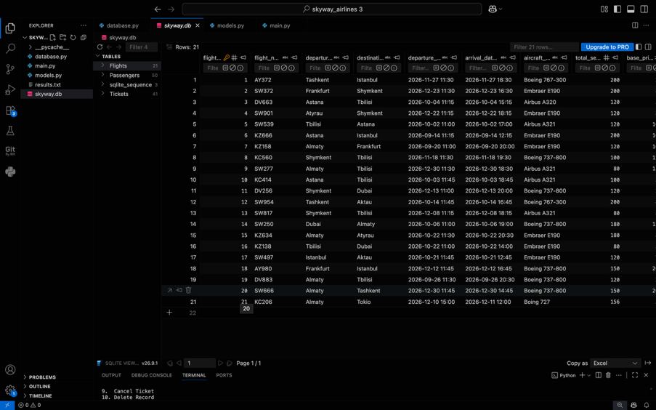

Figure 1. Database structure of the Airline Reservation System.

4. Main Function
Main Function — main.py. The main.py file controls the console menu and the main program operations. Its functions allow users to add flights, passengers, tickets, display records, search for information, update or delete records, cancel tickets, show statistics, and export reports. The main () function manages the program flow. It displays the menu, receives the user's choice, and calls the appropriate function using conditional statements and loops.
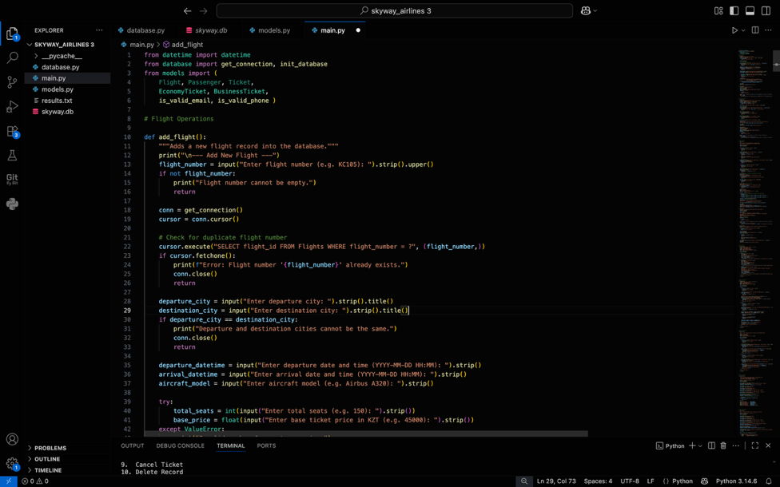
Figure 2. Main menu of the Airline Reservation System.

5. Classes methods
Classes Module — models.py. The models.py file defines the Flight, Passenger, and Ticket classes. The Flight class stores flight information, while the Passenger class stores passenger details. The Ticket class represents ticket bookings and contains a method for calculating ticket prices.
The EconomyTicket and BusinessTicket classes inherit from the Ticket class and override the calculate_price () method. Economy tickets use a price multiplier of 1.0, while business tickets use a multiplier of 1.8.
The module also includes the is_valid_email () and is_valid_phone () functions, which use regular expressions to validate email addresses and phone numbers.
The project demonstrates object-oriented programming, inheritance, method overriding, input validation, and reusable functions.
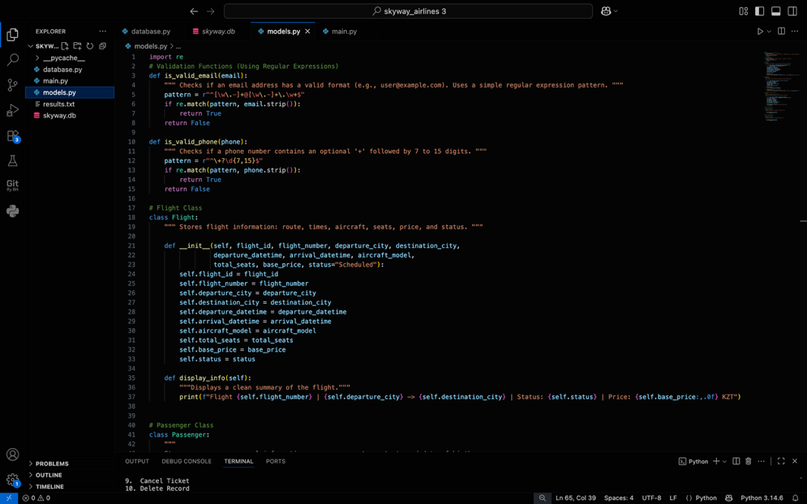
Figure 3. Main classes and program functionality.

6. Calculations and Results
Our program calculates the total ticket revenue and seat occupancy rate using data from the database.
The total ticket revenue is calculated by adding the prices of all booked tickets. According to our results, the total revenue is 3,513,000 KZT.
The seat occupancy rate shows how many seats are occupied by booked tickets. We calculate it by dividing the number of booked tickets by the total number of seats and multiplying by 100%.
Seat Occupancy Rate = (37 / 2,896) × 100% = 1.28%
Our database contains 21 flights, 50 passengers, and 41 tickets. Among these tickets, 37 are booked and 4 are cancelled. The program also saves the results in the results.txt file, so users can easily view the statistics.
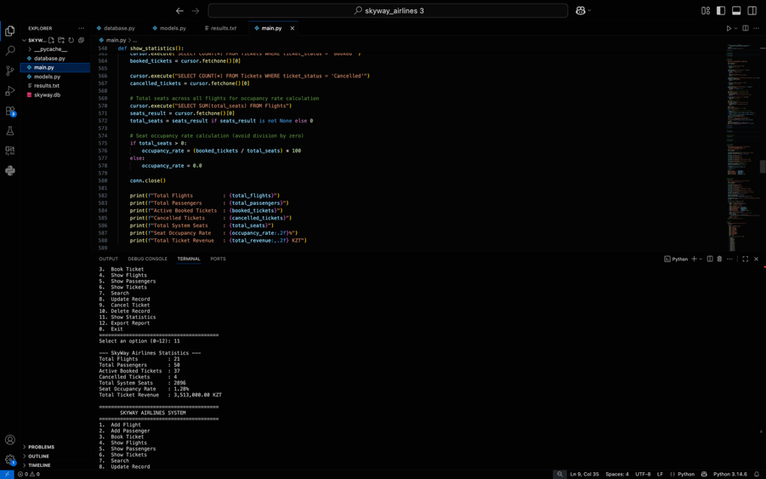
Figure 4. Program statistics or the results.txt file.

7. Team Contributions
- Aidarkhankyzy Assel: worked on the models.py module, main.py (def search_records (), def update_record ()) and prepared the project report.
- Zaytsev Ilya Stanislavovich: worked on the database.py module, main.py functions (def add_flight (), def show_flights (), def add_passenger (), def show_passengers (), def show_tickets (), def cancel_ticket ()) and prepared the project presentation.
- Yunusov Ismail Gaidarovich: worked on the main.py module (functions: def book_ticket (), def delete_record (), def show_statistics (), def export_report (), def main ()) and implemented the main program operations.
8. References
[1] OpenFlights Airports Database. (2017). Airport, airline and route data. (https://openflights.org/data.php)

